Banker’s Algorithm
# Source: AI Source: Provided by: [Data Path: Persons Table -> ID Column: 1, Name_En Column: Motasem Essam] -> From: [ChatGPT] on [1/21/2026]
Banker’s Algorithm is a classic deadlock avoidance algorithm used in Real-Time Systems (RTS) to ensure that resource allocation never leads to a deadlock. It was introduced by Edsger W. Dijkstra and is widely used in operating systems.

Definition
# Source: AI Source: Provided by: [Data Path: Persons Table -> ID Column: 1, Name_En Column: Motasem Essam] -> From: [ChatGPT] on [1/21/2026]
The Banker’s Algorithm is a resource allocation and deadlock avoidance algorithm that:
- Simulates resource allocation “in advance” before granting a request.
- Ensures the system remains in a safe state, where all tasks can eventually complete.
- Denies a request if granting it could potentially lead to an unsafe state.
It is called the “Banker’s Algorithm” because it is similar to a banker lending money: resources are granted only if it won’t risk insolvency (deadlock).

Key Concepts
# Source: AI Source: Provided by: [Data Path: Persons Table -> ID Column: 1, Name_En Column: Motasem Essam] -> From: [ChatGPT] on [1/21/2026]
- Safe State
  - A system state is safe if there exists a sequence of task execution where all tasks can finish without waiting indefinitely.
- Unsafe State
  - Granting a request that may lead to no possible sequence of task completion → system may deadlock.
- Resource Request Checking
  - For each request, the algorithm checks if granting it keeps the system in a safe state.

Data Structures Used
# Source: AI Source: Provided by: [Data Path: Persons Table -> ID Column: 1, Name_En Column: Motasem Essam] -> From: [ChatGPT] on [1/21/2026]
- Available – Vector of available resources.
- Max – Matrix of maximum resource needs of each task.
- Allocation – Matrix of current resource allocations.
- Need – Matrix of remaining resources needed by each task (Need = Max − Allocation).

Algorithm Steps
# Source: AI Source: Provided by: [Data Path: Persons Table -> ID Column: 1, Name_En Column: Motasem Essam] -> From: [ChatGPT] on [1/21/2026]
- When a task requests resources:
  - Check if request ≤ Need
  - Check if request ≤ Available
- Pretend to allocate resources:
  - Available = Available − Request
  - Allocation = Allocation + Request
  - Need = Need − Request
- Check if resulting state is safe:
  - If yes → grant request
  - If no → task must wait

Example
# Source: AI Source: Provided by: [Data Path: Persons Table -> ID Column: 1, Name_En Column: Motasem Essam] -> From: [ChatGPT] on [1/21/2026]
Suppose a system has:
- 3 resources (R1, R2, R3)
- 2 tasks (T1, T2)
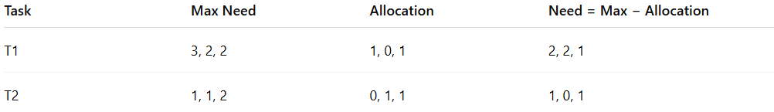
Task | Max Need | Allocation | Need = Max − Allocation
T1 | 3, 2, 2 | 1, 0, 1 | 2, 2, 1
T2 | 1, 1, 2 | 0, 1, 1 | 1, 0, 1
Available Resources: 1, 1, 0
- T1 requests (1, 0, 1) → check safe state
- After simulation → safe sequence exists → request granted
- Deadlock is avoided because the system remains in a safe state.

Advantages
# Source: AI Source: Provided by: [Data Path: Persons Table -> ID Column: 1, Name_En Column: Motasem Essam] -> From: [ChatGPT] on [1/21/2026]
- Prevents deadlocks before they occur.
- Ensures system reliability in resource allocation.
- Provides predictable task execution.

Disadvantages
# Source: AI Source: Provided by: [Data Path: Persons Table -> ID Column: 1, Name_En Column: Motasem Essam] -> From: [ChatGPT] on [1/21/2026]
- Requires knowing maximum resource needs in advance.
- Computationally expensive for large systems.
- Not suitable for dynamic or unpredictable systems where tasks’ resource requirements vary.

Why Banker’s Algorithm Matters for Software Engineers
# Source: AI Source: Provided by: [Data Path: Persons Table -> ID Column: 1, Name_En Column: Motasem Essam] -> From: [ChatGPT] on [1/21/2026]
- Critical for real-time and embedded systems with limited resources.
- Helps design robust resource allocation strategies.
- Teaches safe state analysis and proactive deadlock prevention.

